一．两种方法的简介（没有intext引用，可以结合轩找的进行修改）
Diffie–Hellman (D-H):
Diffie–Hellman (D-H), first introduced by Diffie and Hellman in 1976, is a foundational public-key agreement protocol that allows two parties to establish a shared secret over an insecure channel. The protocol relies on the difficulty of the discrete logarithm problem in a finite cyclic group: each party selects a private exponent and exchanges the corresponding public values; the shared secret is computed by exponentiation of the received public value with the local private exponent. D-H underpins many key exchange mechanisms but, in its basic form, lacks entity authentication and therefore is vulnerable to active network attacks if additional protections are not applied.
RSA (as key transport):
RSA, introduced by Rivest, Shamir and Adleman, is widely used for both encryption and digital signatures. In key exchange contexts, RSA can be used to encrypt a symmetric key that is then used for session communication. RSA security relies on the pragmatic difficulty of factoring large integers; however, practical implementations can be vulnerable to attacks beyond pure mathematical factoring (e.g., side-channel attacks) if the implementation leaks information such as timing, power consumption, or error responses.
- 觉得好写好实现的技术
对于D-H选择MITM 对于RSA选择TIMING
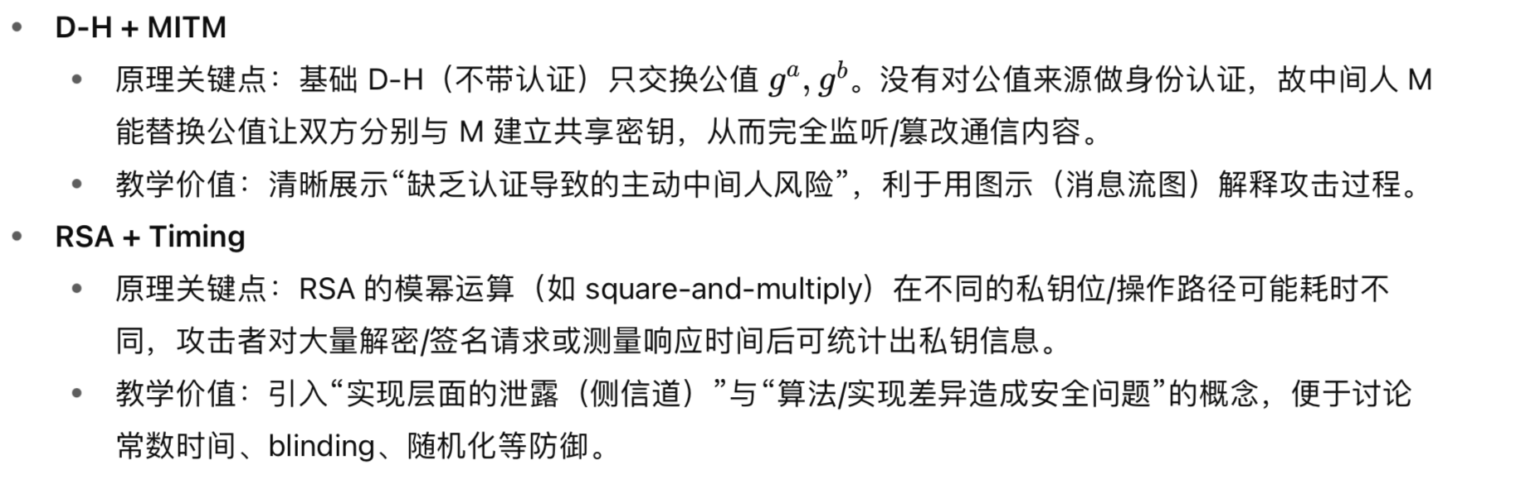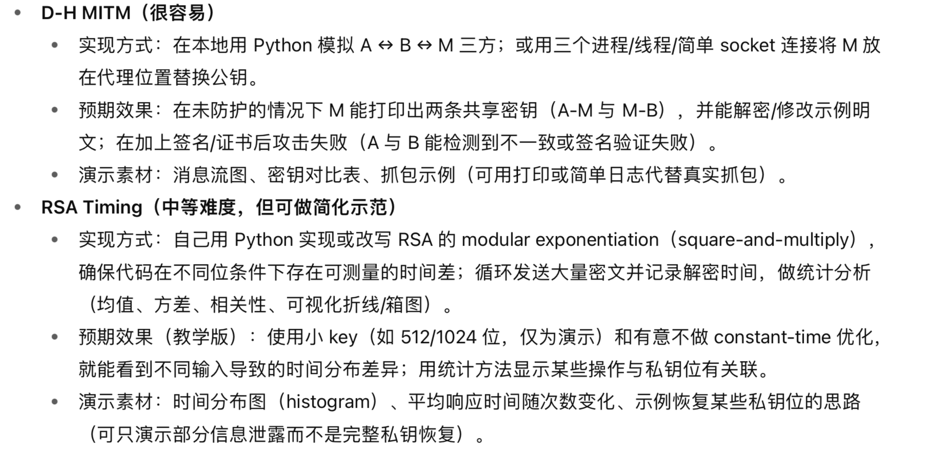
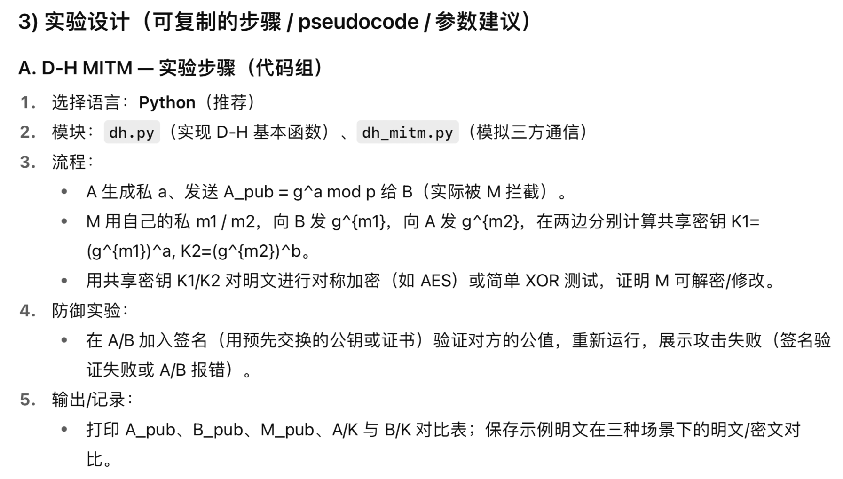
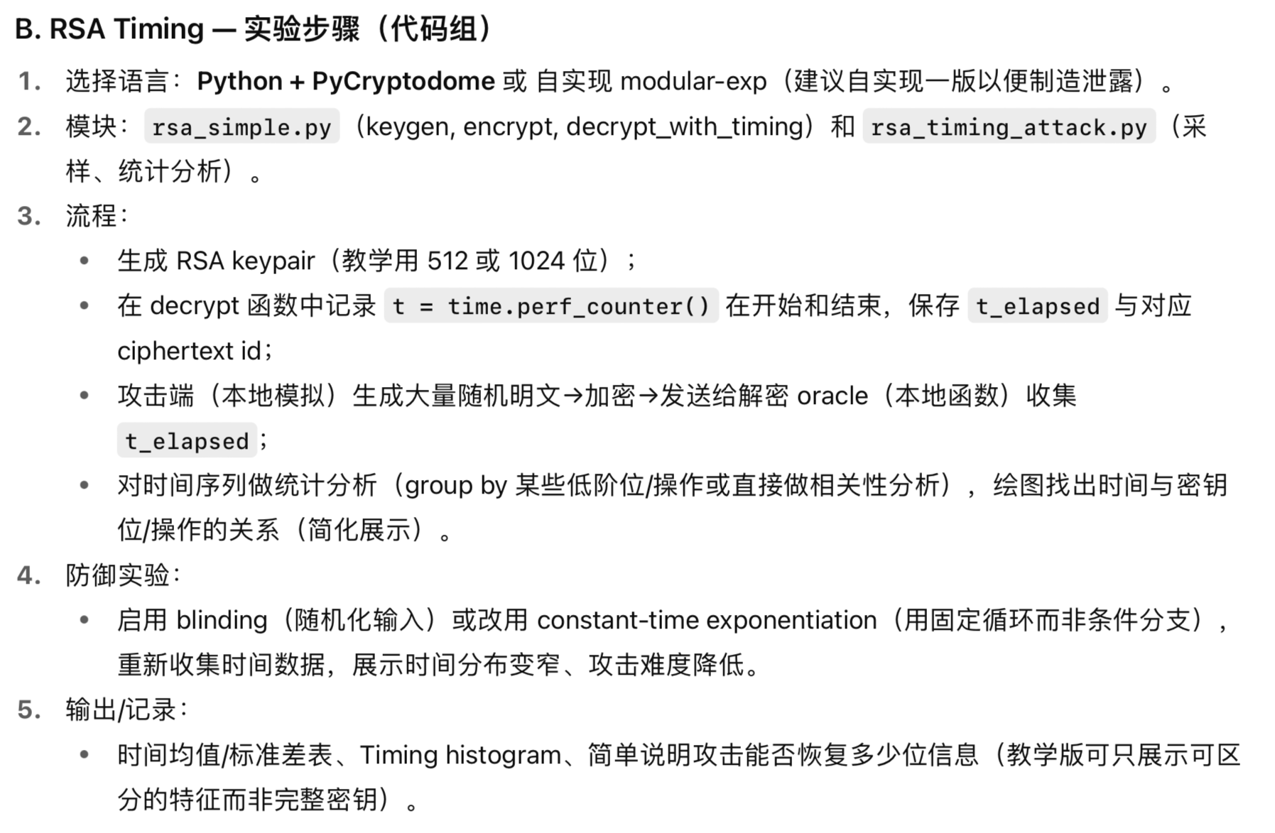
- 可能能用上的参考文献

- Paul C. Kocher – “Timing Attacks on Implementations of Diffie-Hellman, RSA, DSS, and Other Systems”（Springer）
主要内容：时间侧信道如何用于对 RSA 和 D-H（及 DSS）实施攻击，并且提出几种防御思路，写RSA timing attack的理论基础时可用。
- “Authenticated Key Exchange Provably Secure against the Man-in-the-Middle”（Springer）
主要内容：讨论一种经过认证的密钥交换协议，从理论上保证它不容易受到 MITM 攻击。写D-H的防御部分可用。
- “Preventing Man-In-The-Middle Attack in Diffie-Hellman Key Exchange Protocol”（research gate）
主要内容：综述了对 D-H 的 MITM 攻击与已有防御方法，并提出一种新方法增强随机性 /完整性验证的方案。可用于写防御部分的参考。
- Detector: An approach for detecting, isolating, and preventing timing attacks（Elsevier）
主要内容：提出一个运行时检测 / 隔离 / 防止 timing side-channel 攻击的方法（ “Detector”）。在防御部分可引用这一思路。

